**Photography Gamified Web App:**

A **Progressive Web App (PWA)** or **React Native App** used to gamify photography via challenges based of photography genres, styles, locations, objects and more.

Images posted for challenges **will show detailed metadata** from the image, this will include:

* Camera Make/Model
* Focal Length
* Aperture
* ISO
* Shutter Speed

This level of detail will be good for other photographers to learn the process behind winning shots and therefore help them develop their skills. However, due to potential privacy concerns **posting this data will be optional**.

Challenges will be judged by the userbase using a rating ELO system, like what is seen on sites like reddit. There will be no hidden AI based algorithm used to show images, this is because I believe the AI approach to recommendation, although interesting, often results in poorer quality content. Putting the userbase in control gives a better sense of engagement and relevancy within the app.

Users will be able to gain achievements/badges for completing challenges and other related goals. These will be able to be displayed on the user’s profile.

**App Architecture:**

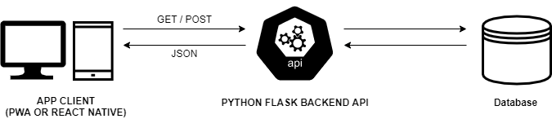

**Stack:**

* HTML/SCSS
* JS (Potentially Typescript)
* Python (Flask)
* MYSQL or MongoDB
* Potentially React Native

**Task Breakdowns:**

**Report:**

* Aggregate a list of potentially useful sources.
* Sort through list to weed out potentially weak sources.

**Backend:**

* Database Selection (SQL or NOSQL)
* Database Schema Design.
* REST API development.
* Initial API testing via curl.
* Final Testing of API once the frontend has been developed.

**Frontend:**

* Select Web App Type (PWA or React Native).
* UI/UX Design.
* App Design (UML Diagrams e.t.c).
* App Development.
* App Testing